CA1603

CA1603 is designed to polish optical lenses and ophthalmic lenses to achieve high polishing efficiency and high surface quality at a reasonable cost. Its greatest advantage is high stock removal .
Parameters | Unit | Typical data | LSL | USL
D50 | um | 1.43 | 1.0 | 2.0
D97 | um | 5.45 | -- | 7
Bulk density | g/cm³ | 1.64 | 1.4 | 1.8
PH | -- | 7 | 6 | 8

Typical PSD
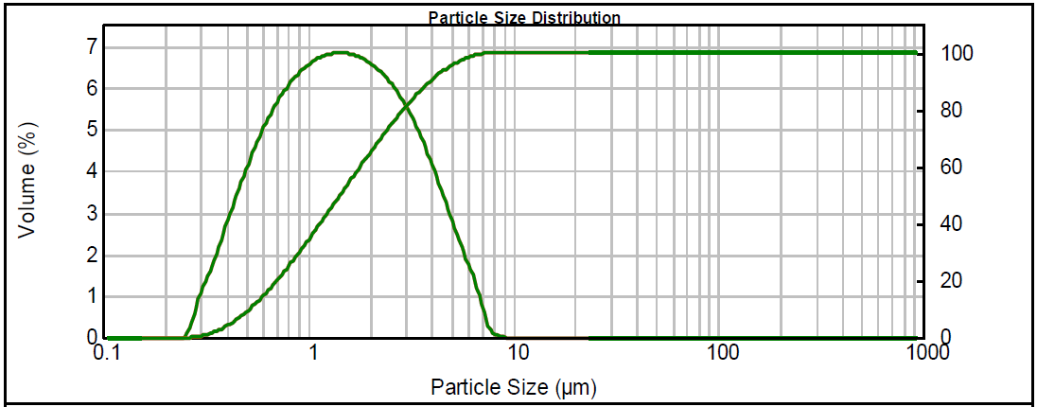

Polishing parameters for reference：
Polisher | Polishing pad | Presure  (MPa) | Slurry flow rate | Glass polished | Principal axis  (rpm) | Swing frame  (rpm) | Slurry  Concentration  (wt%) | Surface  finish | Polishing  time  (Min) | Typical stock  removal(mg)
JPX012.2A | LP66 | 0.3 | Fixed | K9  (φ65.0*1.04cm) | 1000 | 34.96 | 2% | Good | 3 | 54.7

Technical References

- Use the following pre-mixing method to increase polishing efficiency, reduce rework, reduce cerium oxide usage, and increase throughput:
- Calculate the mixing ratio according to the target slurry concentration (Baume). Please use warm water of 25-35 °C;
- Add the water to a clean container as calculated;
- Stir to disperse the ceria polishing solution;
- Weigh the ceria polishing liquid solution into the warm water according to the determined mix ratio and stir well;
- Add 250 mL of the mixed slurry to the measuring cylinder;
- Drop a hydrometer into the measuring cylinder to measure the Baume. Adjust the mixing ratio to get the target Baume reading if necessary. After each adjustment, steps 5 and 6 should be repeated until the target hydrometer reading is reached.
Note: The Baume of the mixed slurry should be measured every two hours or at least twice a day.

- We also recommend that pH should be monitored. Ceria slurry cut rates are optimized at high pH, and alkalinity may changes during the polishing process. . It is important to monitor and control pH during glass polishing, as some glass types can corrode when the pH range is not correct.
.

